**CHẤT LÀM MỀM VẢI**

1. **Propanol:** 12.7% (C3H8O)

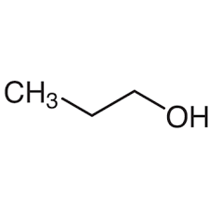Propan-1-ol

**CAS no.:**71-23-8

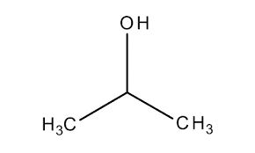

Propan-2-ol

**CAS no.:**67-63-0

1. **Propylene glycol:** 1.8% ([C3H8O2](https://pubchem.ncbi.nlm.nih.gov/#query=C3H8O2) or CH3CHOHCH2OH)

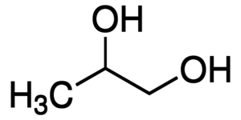 1,2-Propanediol

**CAS no:** 57-55-6

1. **Isopropyl cellosolve:** 1% (C5H12O2)

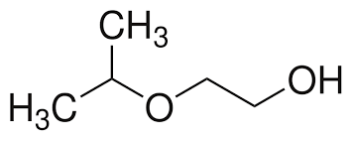Tên khác: Ethylene glycol isopropyl ether, β-Hydroxyethyl isopropyl ether, Isopropyl glycol, [2-Isopropoxyethanol.](https://www.googleadservices.com/pagead/aclk?sa=L&ai=DChcSEwistIHotfj6AhW0N3IKHRpkD6gYABAAGgJzZg&ase=2&ohost=www.google.com&cid=CAESauD2LgpnvYKWU5_gd7JB_v46PnlNc53yUb0uAYVmGv02-SNbRtB743yyh0z-GlTBbIZXpje05tF58Sf457T0czzzs6M5WBVZzSL_nU20coNat6-TG22D533aCFhmi1Gp1PAYVajgggEBHs0&sig=AOD64_3PNhg3dtjGhY_ri1x2eaHmBiWqeQ&q&nis=4&adurl&ved=2ahUKEwjUn_vntfj6AhU7cGwGHcNGAq4Q0Qx6BAgIEAE)

**CAS no.:** 109-59-1

**4. Vari soft 238** (N,N-Bis(tallowamidoethyl)-N-(2-hydroxy)methylammonium methyl sulfate

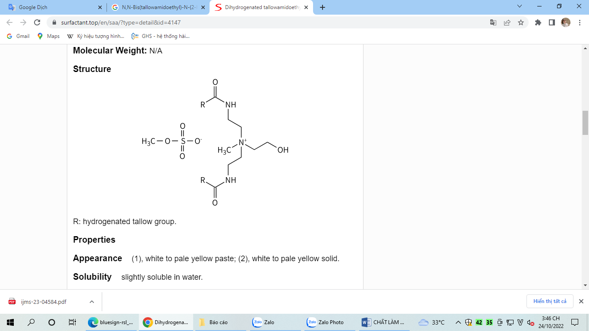Tên khác: Dihydrogenated Tallowamidoethyl Hydroxyethylmonium Methosulfate

**Cas no.:** 68953-59-3

**HỒ VẢY**

1. **Ammonium acetate** (CH3COONH4): 17%

Cas no.: 631-61-8

1. **Diglyceride, triglyceride của Palmitic acid và Stearic acid**

Palmitic acid: CH3(CH2)14COOH

Stearic acid: CH3-(CH2)16-COOH

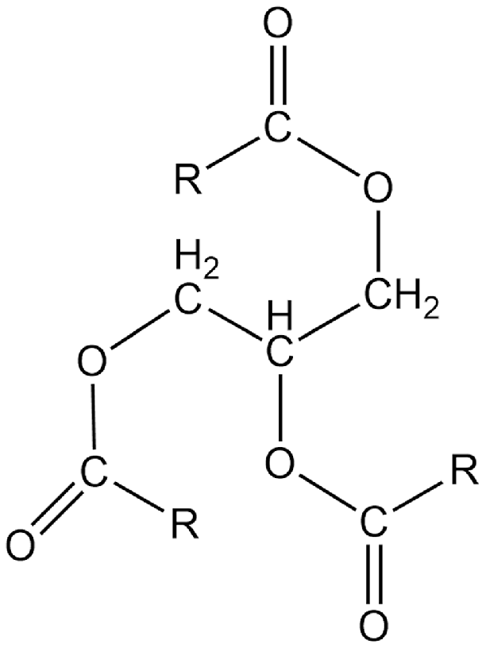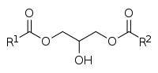

Diglyceride

Triglyceride